Parent tutorial for adding photos and observations
- Log in to your Tapestry account (if you need your account activation link resent please let Lindsey or a member of the Pre-school Team know and we will be happy to reset for you.)
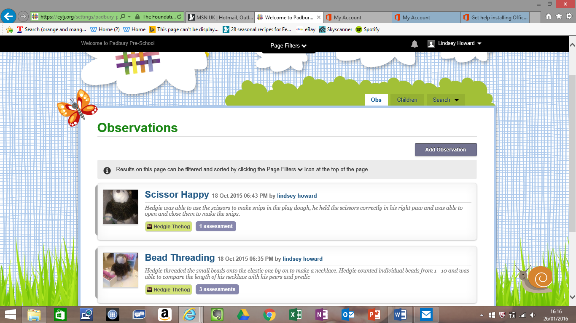
- Click on tab ‘add observation’ (see image below), this will open a new page.

- Follow the boxes as in the picture below. Use the drop down box to add your child’s name, click on the title box to insert text, click on notes to add some information about the observation. You may want to include:
- holidays
- weekends away
- day trips
- any groups they attend ballet, dance, music lessons
- what we did at the weekend
- [insert name] has learnt to…
- spending time with grandparents
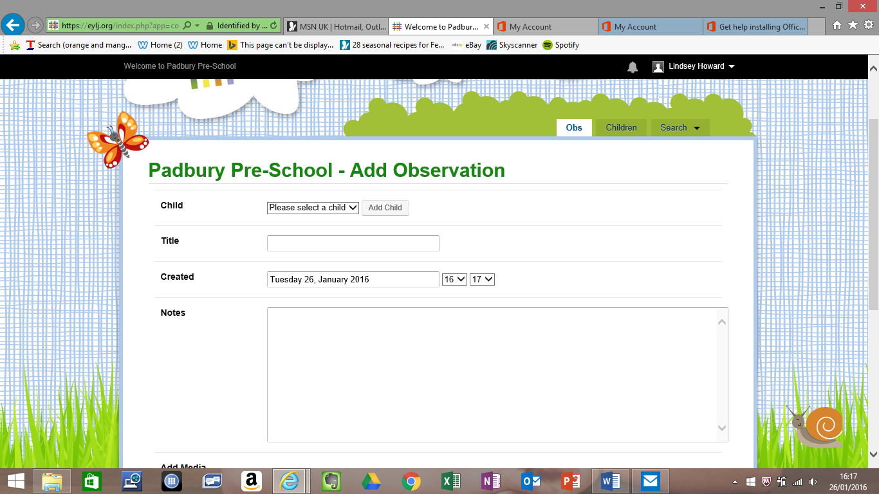
- special events or celebrations

Adding photographs
- Scroll down to see the ‘Add media’ section. Click on Add Files and it will automatically give you the choice to select photos from your device (computer/tablet/phone) once the file appears in the blue shaded section click ‘Start Upload’. Note: If you do not upload the photo using this green tab the photo will not display. When you have finished be sure to click on save (bottom middle of screen as shown).
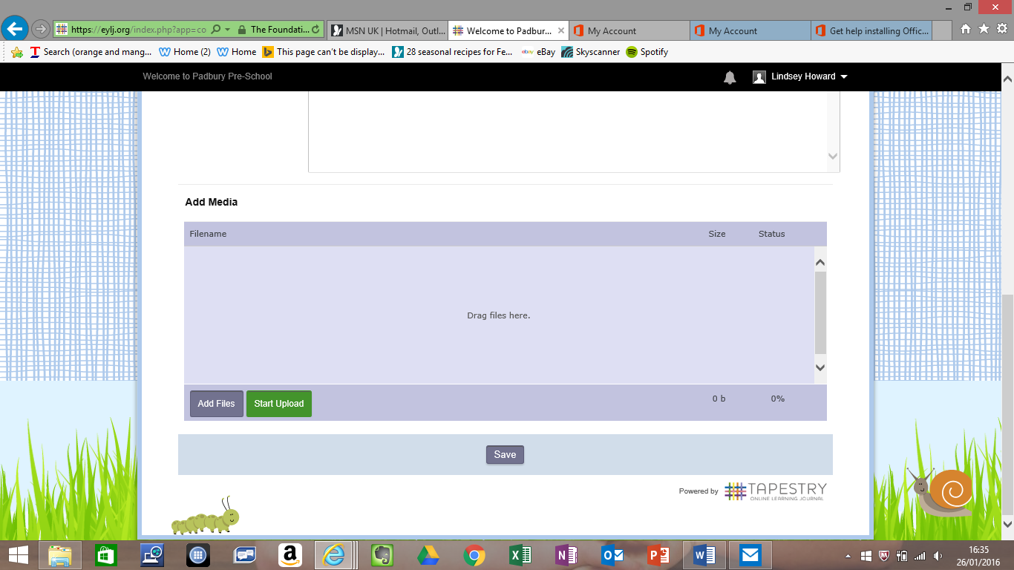
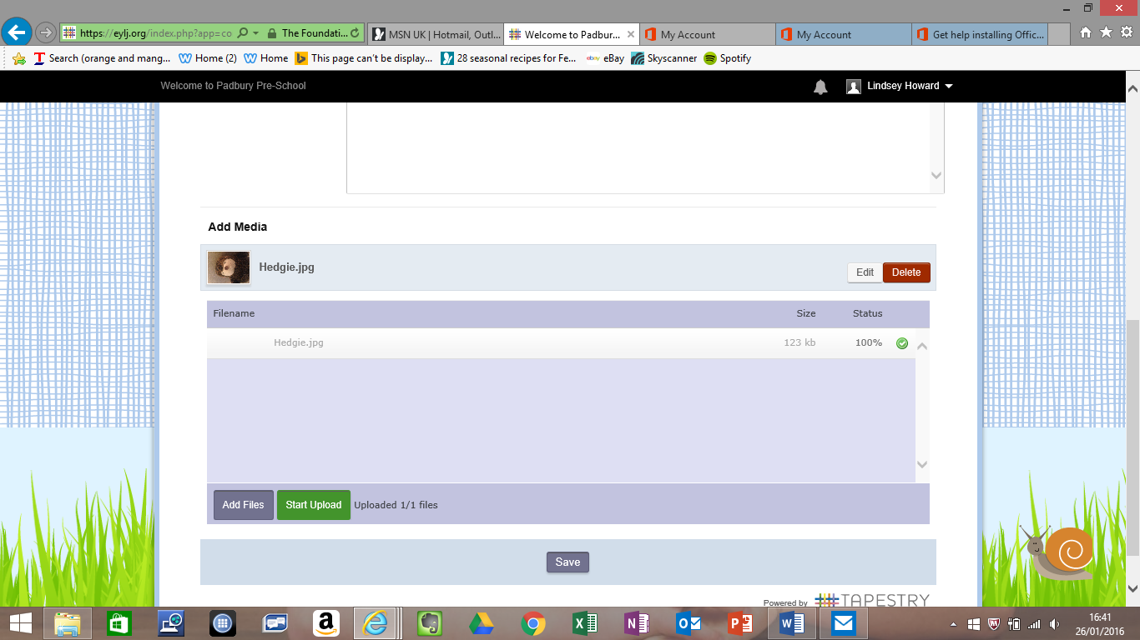
File will show here.
When you are complete you must click save for your record to be uploaded to your child’s profile.
You can delete or change images by clicking here

